# Computer Programming Lab 12

**Nabeel Ali BEE173059 Section-3**

# Activity 1:

#define _CRT_SECURE_NO_WARNINGS

#include<stdio.h>

struct students {

char name[10];

char reg_no[10];

float cgpa;

}student[10];

FILE *fptr;

int main()

{

int i;

fptr = fopen("Student_Records.txt", "w");

for (i = 0; i < 10; i++)

{

if (fptr == NULL)

{

printf("Error. File not found\n");

break;

}

printf("enter name of the student %d ", i + 1);

scanf("%s", student[i].name)

printf("enter the registration number of the student %d ", i + 1);

scanf("%s", student[i].reg_no);

printf("enter the CGPA of the student %d", i + 1);

scanf("%f", &student[i].cgpa);

fprintf(fptr, "%s\n", student[i].name);

fprintf(fptr, "%s\n", student[i].reg_no);

fprintf(fptr, "%f\n", student[i].cgpa);

}

fclose(fptr);

}

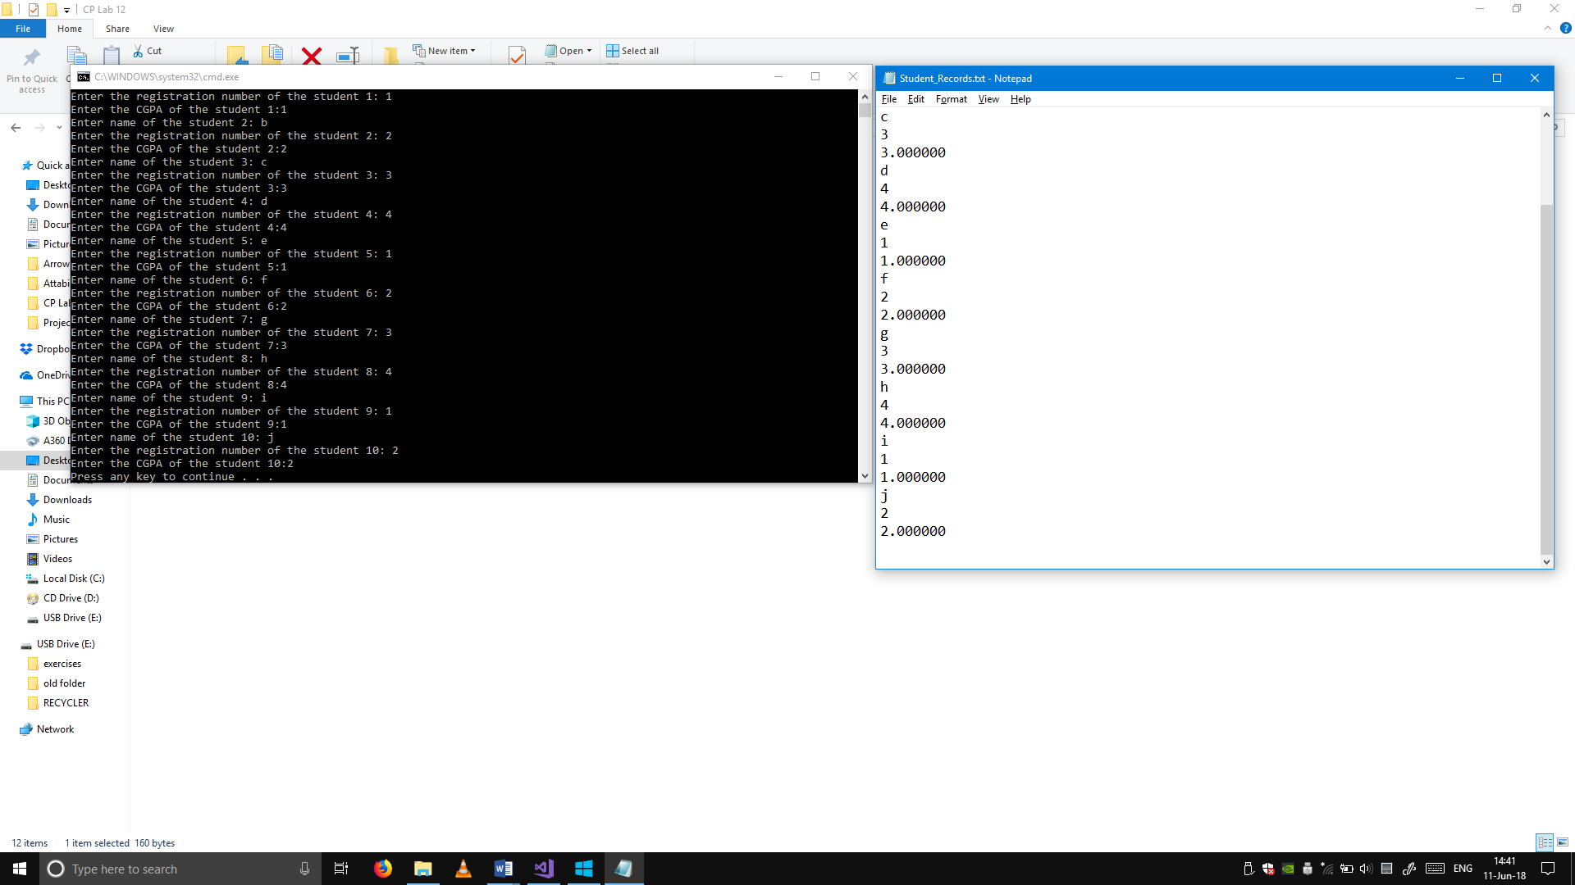

## Activity 2:

#define _CRT_SECURE_NO_WARNINGS

#include <stdio.h>

struct students {

char name[10];

char reg_no[10];

float cgpa;

}student[10];

FILE *fptr;

int main()

{

int i;

struct students student[10];

fptr = fopen("Student_Records.txt", "r");

for (i = 0; i < 10; i++)

{

if (fptr == NULL)

{

printf("Error. File not found\n");

break;

}

fscanf(fptr, "%s", student[i].name);

fscanf(fptr, "%s", &student[i].reg_no);

fscanf(fptr, "%f", &student[i].cgpa);

printf("Name: %s\n", student[i].name);

printf("Reg. no. %s\n", student[i].reg_no);

printf("CGPA = %f\n\n", student[i].cgpa);

}

fclose(fptr);

}

